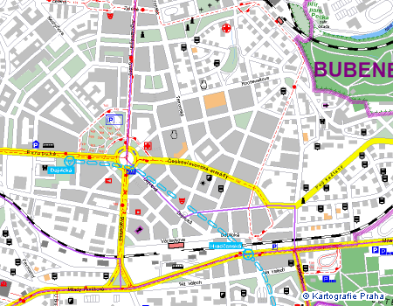
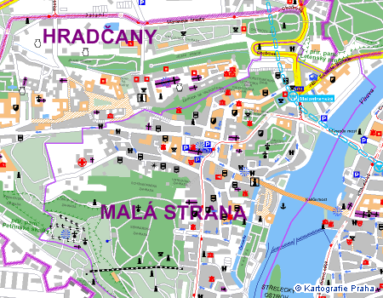
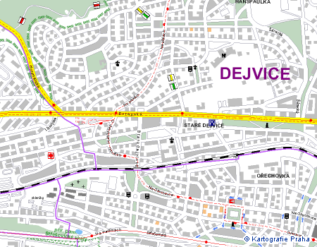
◆
❖
⬥
1aa

2a

◆

3 | 2
 | 1

Itinerary from the Conference venue to Accommodation Facilities in Masarykova kolej (2a):

From | To | By
Novotneho lavka | Staromestska | On foot or by tram No.17, 18 from Narodni divadlo st.  (1 way station, it is possible to walk)
Staromestska | Dejvicka | Metro line A
Dejvicka | Thakurova | On foot or by tram No. 2, 20 a 26  (1 way station, it is possible to walk)

2a
Stop tram No. 2, 20, 26: Thakurova
Masarykova kolej
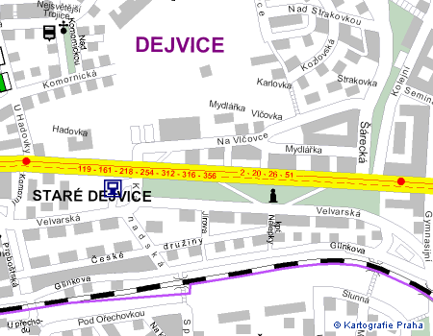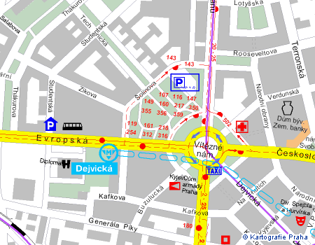

Conference venue
Metro line A – stop Staromestska

(5 minutes on foot from the Conference venue)
Masarykova kolej (entrance from Thakurova street)

Thakurova 1,160 41 Praha 6
Tel.: +420-233 051 237
Fax.: +420-233 051 112
E-mail: masaryk@suz.cvut.cz
www: http://web.cvut.cz/cp1250/sf/k_masarykova.html

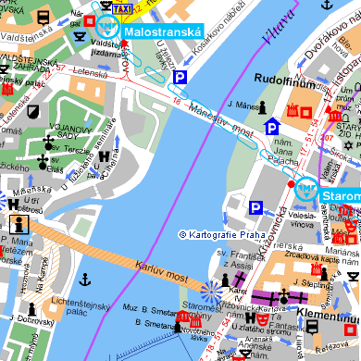
1aa

