Long-term Experimental Monitoring and Theoretical Modelling
of the Surface Runoff Formation in the Sumava and Jizera Mts. (Czech Republic)

Buchtele, J.(1), Kulasova, A.(2), Tesar, M.(1) and Sir, M.(3)

(1) Institute of Hydrodynamics Academy of Sciences of the Czech Republic, Pod Patankou 5, CZ 166 12 Praha 6, Czech Republik
(2) Czech Hydrometeorological Institute, Na Sabatce 17, CZ 143 06 Praha 4, Czech Republic
(3) Litvinovice 47, CZ 370 05 Ceské Budejovice, Czech Republic

The article deals with the observation, evaluation and modelling of the surface runoff formation in the head water regions in the Czech Republic. Its main aim is to present simulations of rainfall-runoff process in which two distinct models have been used - Sacramento Soil Moisture Accounting model and BROOK90 - taking into account:

(i) long-term influence of the land-use changes caused by the deforestation, urbanization and intensive agriculture;

(ii) the influence of the soil moisture in the basin;

(iii) the influence of the amount of evapotranspiration during vegetation season (estimated by several methods: energy balance method, hydropedological method and the BROOK90 model).

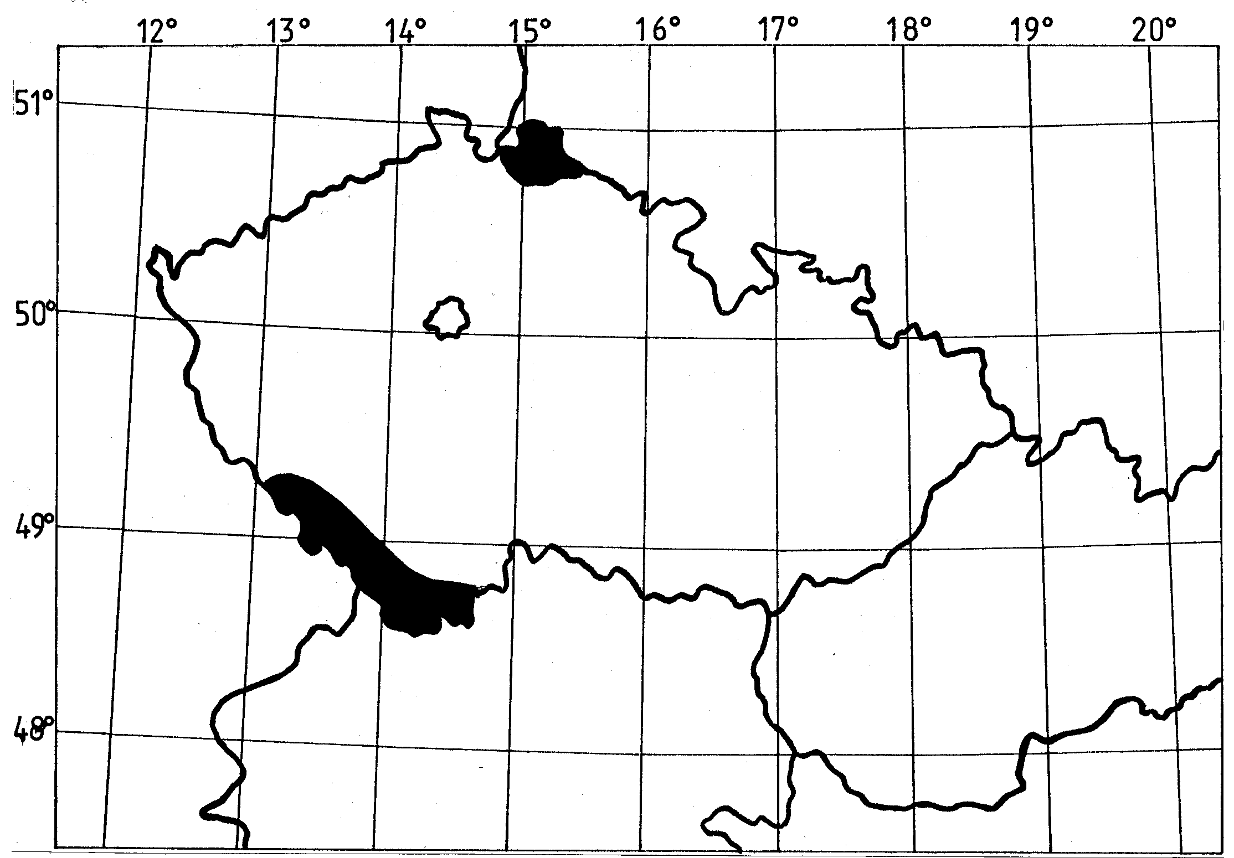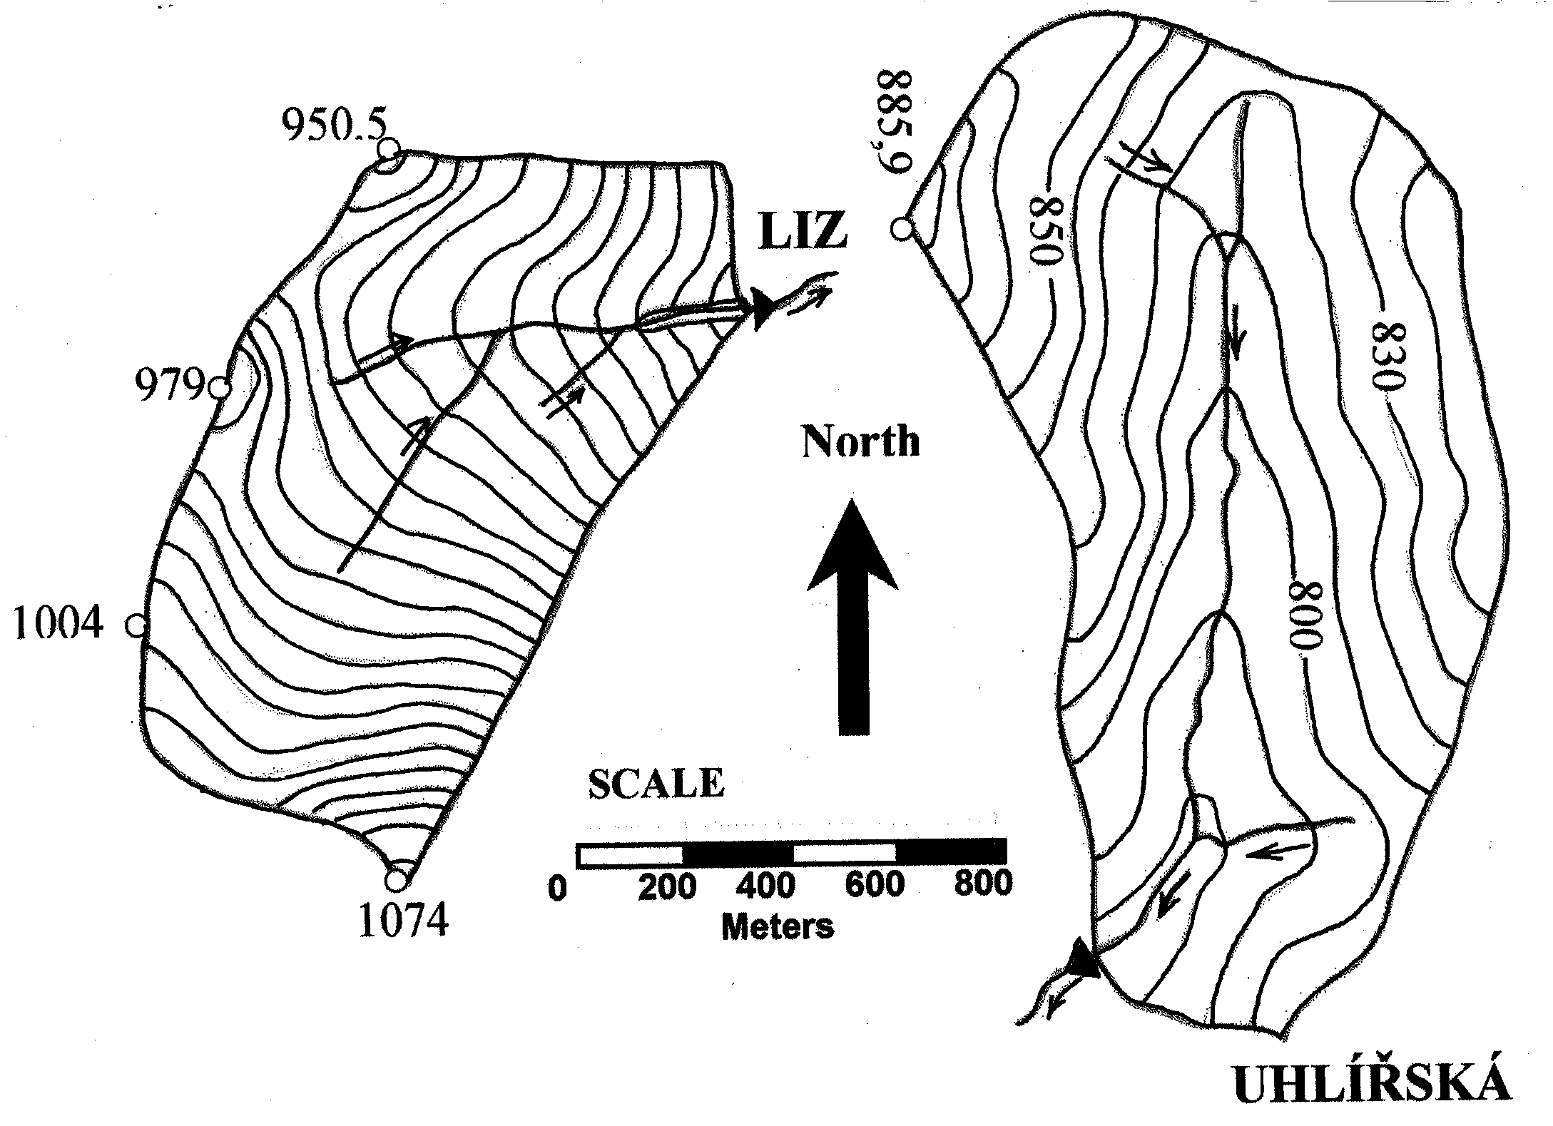

Two research basins presented in this study were set up as representative basins for investigation of the hydrological cycle, with the general purpose to extrapolate the results in time and space: the Liz basin in Southwest Bohemia and the Uhlirska basin in Northern Bohemia (Czech Republic). From both catchments data sets are available, including rainfall and flows, dating back to the mid-1970’ (Liz basin) and beginning-1980´(Uhlirska basin).

Poland
1
2
1
2

Germany

Czech Republic

Slovakia
Austria

Fig. 1. Situation of the Sumava Mts. (1) and Jizerske hory Mts. (2) in the Czech Republic with the experimental catchments Liz and Uhlirska.

The Liz catchment operated by the Institute of Hydrodynamics of the Academy of Sciences is situated in central part of the Sumava Mts. This mountainous basin lies near the border among the Czech Republic, Germany and Austria (see Fig. 1). The drainage area of this basin is 0,989 km², the elevation ranges from 828 to 1074 m a.s.l. (see Fig. 1A). The mean annual air temperature is 6,6 ºC, annual precipitation total ranges from 665 to 1142 mm, mean discharge is 0,010 m³.s⁻¹ (1976 – 1997). Vegetation cover is formed by mixed forest with the average age of about 84 years. Prevailing type of the trees is spruce (88 %) with fir, larch, beech, pine, etc. The human influence can be neglected now, but in the beginning of 1980’ about 6 % of the drainage area were harvested.
The Uhlirska basin operated by the Czech Hydrometeorological Institute is located in the Northern part of the Czech Republic in the Jizerske hory Mts. (see Fig. 1). The basin is underlain by granite rock. The drainage area of this basin is 1,870 km², the elevation ranges from 775 to 886 m a.s.l. (see Fig. 1B). The mean annual air temperature is 5,1 ºC, annual precipitation total ranges from 934 to 1375 mm, mean discharge is 0,058 m³.s⁻¹ (1982 – 1997). This basin was from 95 % covered with forest, mainly spruce and interspersed birch, ash and beech. In beginning of 1980´s forest was severely damaged (air pollution, insect, frost and wind damages). Only 37 % of forest area was without signs of damages.

- The runoff changes due to changed vegetation cover and to other changes are not usually abrupt. Therefore the task to detect the gradual development of runoff process is not trivial problem and it is advisable to analyse long-term data. In our case the data sets from these two experimental basins were used for analyses and for simulations of precipitation-runoff process as detailed as possible. As the tools for simulations two rainfall-runoff models have been used:
- The physically structured model BROOK´90 (Federer, 1995), developed in the U.S. forest Service;
- The conceptual water balance model SAC-SMA (Sacramento Soil Moisture Accounting), developed in the U.S. National Weather Service (Burnash, 1995)

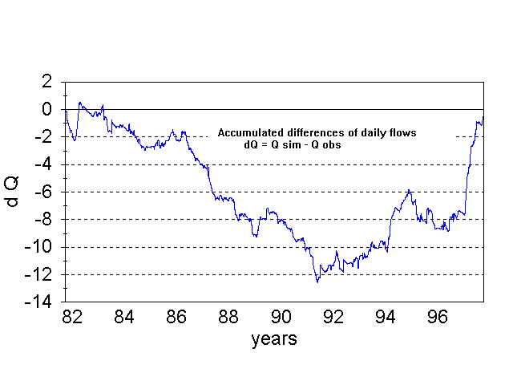 | 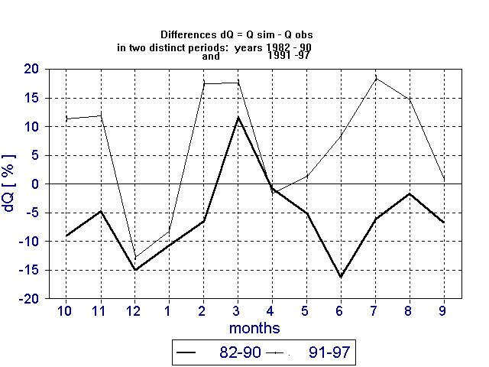
Fig. 2. Differences between simulated and observed outflows of Uhlirska basin using SAC-SMA model indicating effect of deforestation due to acid rains.

The outputs of these models, which illustrate the appearing changes in runoff and corresponding evapotranspiration are presented in Figs. 2 and 3.

Model BROOK´90 is able to simulate realistically dynamics of evapotranspiration, but it requires more input data, e.g. solar radiation and wind velocity, and it does not provide the reliable results concerning groundwater storages. It has been applied for these small basins, where evapotranspiration processes may be more easily studied and where it has been assessed also by other independent methods, and where long-term components of subsurface storages represent relatively smaller portion of water reserves.
SAC-SMA model has been recently implemented and rather extensively tested in the whole Czech part of the Elbe River basin, where long time series of daily precipitation and discharges are available (Buchtele, 1993). In experiments for Uhlirska basin the calibration has been accomplished using whole period 1982 –1997. Then this interval has been split into two periods and deviations of runoff from ´average´ conditions are -5.0 % Q_{obs} and +6.2% Q _{obs} , i. e. runoff has been changed more than by 11 % Q_{obs.}
The attention has been given also to the influence of the soil moisture on the surface runoff formation. The soil moisture condition over the basin areas was assessed with the aid of the hydropedological balance method using tensiometric measurements made in 2-day intervals and daily precipitation amounts. Retention curves were used in the recalculation of tensiometric data as data on soil moisture, and thus also on the volume of soil water. The retention curves of individual genetic soil horizons were obtained by the inverse solution of Richard's equation (Sir et al., 1988).

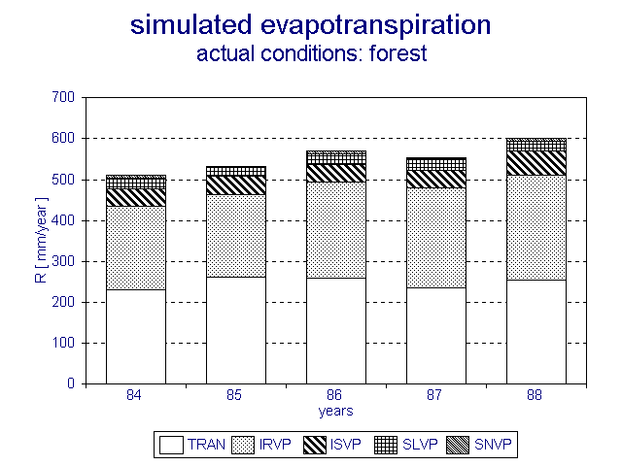 | 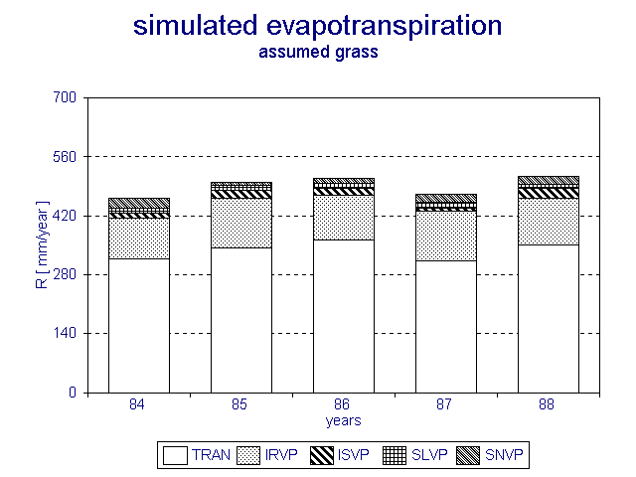

Fig. 3. Simulated evapotranspiration components using the BROOK model – Liz basin TRAN ... transpiration, IRVP ... rain interception, ISVP ...snow interception, SLVP ... soil evaporation, SNWP ... snow evaporation

The estimation of potential evapotranspiration (PET) of vegetation cover during the growing season was evaluated as the water requirements for plant cooling (Prazak et al., 1994; 1996). The calculation uses hourly values of air temperature and of global radiation totals. Properties of the vegetation cover are expressed in terms of two phenomenological constants, i.e. the effective absorptivity and the effective thickness of leaves (or needles). Both parameters were ascertained by calibration.

Acknowledgements
The authors acknowledge the support of Grant Agency of the Czech Republic (Grant No. 526/98/0805 and No. 205/99/1561) and Grant Agency of the Academy of Sciences of the Czech Republic (Grant No. A30600001).

References
Buchtele, J.: Runoff changes simulated using a rainfall-runoff model. Wat. Resour. Manage. 7(8), 1993, 273 – 287.
Burnash, R.J.C.: The NWS River Forecast System - Catchment modeling. In: Singh,V.P. (ed.) Computer Models of Watershed Hydrology. Water Resources Publications, ISBN No. 0-918334-91-8, 1995.
Federer, C. A.: BROOK 90 - A Simulation Model for Evapotranspiration. Soil Water and Streamflow. USDA Forest Service, Durham, New Hampshire, USA, 1993.
Prazak, J., Sir, M., Tesar, M.: Estimation of plant transpiration from meteorological data under conditions of sufficient soil moisture. J. of Hydrol., 162, 1994, 409-427.
Prazak, J., Sir, M., Tesar, M.: Parameters determining plant transpiration under conditions of sufficient soil moisture. J. of Hydrol., 183, 1996, 425-431.
Sir, M., Kutilek, M., Kuraz, V., Krejca, M., Kubik, F.: Field estimation of the soil hydraulic characteristics. Soil Technol., 1, 1988, 63-75.

