MONITORING AND MODELING OF RUNOFF CHANGES
IN TWO HILLY AREAS IN CZECH REPUBLIC

Buchtele, J.,Buchtelova, M.¹, Kulasova, A., Tesar, M. ¹ and Sir, M.

The results of observation and modelling of runoff and its changes in two headwater areas with similar natural conditions are compared. The aim has been to ascertain the effects of deforestation caused by acid rains in one of these areas.

For simulation of rainfall-runoff process two models have been used with the intention to take into account besides discharge also other phenomena: - influence of evapotranspiration

- temporal variability of sub-surface water storage

Two mentioned research basins are:
• Liz basin in South Bohemia , i.e. in relatively clean area • Uhlirska basin in Northern Bohemia belongs to the region of the so called Black Triangle

In the Liz catchment the human influence can be neglected now, but in the beginning of 1980’ about 6 % of the drainage area were harvested.

The Uhlířská basin was from 95 % covered with forest, mainly spruce and interspersed birch, ash and beech. In beginning of 1980´s forest was severely damaged (air pollution, insect, frost and wind damages). Only 37 % of forest area has been then without signs of damages.
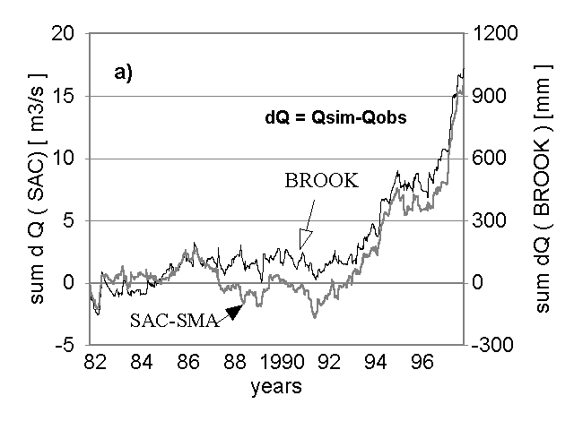 | 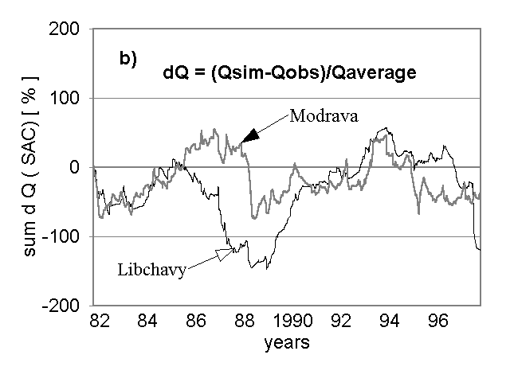
Fig. 1: Accumulated differences between simulated and observed outflows
a) Uhlirska basin, b) basins without changes of vegetation cover

As the tools for simulations two rainfall-runoff models have been used:
- the physically structured model BROOK´90, developed in the U.S. forest Service;
• the conceptual water balance model SAC-SMA (Sacramento Soil Moisture Accounting), developed in U.S. National Weather Service

The runoff changes due to diminished forest cover and due to other changes are not usually abrupt. Therefore the task to detect the gradual development of runoff process is not trivial problem and it is advisable to analyse long time series. The data sets from these two experimental basins have been 23 years and 15 years long.
In experiments for Uhlirska basin the calibration of the SAC-SMA model has been made using shorter series – from years 1982-87 – i.e. before extensive deforestation started. Then the simulations have been carried out for the whole period – years 1982-97 – which provide different shape of graph of accumulated differences. Similar results of the BROOK model are prepared indicating the range of charges in runoff due to deforestation.
Moving averages of simulated and observed annual runoff are evaluated. They have been computed for six year intervals. Similar tendency in differences is again quite apparent.

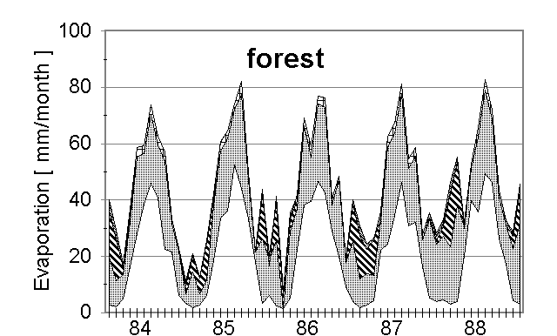 | 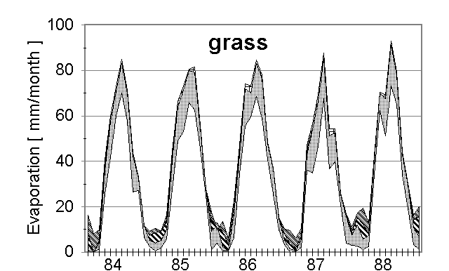


Fig.2. Annual courses of evapotranspiration components

Runoff changes usually appear due to changes of evapotranspiration. Fig. 2 presents proportions of its five components in span of 15 years in the Liz basin. That are results of the BROOK model which has been firstly calibrated for actual vegetation, i.e. for forest cover – Fig. 2a. Fig. 2b shows simulation for grass; LAI – Leaf Area Index and several other parameters characterising this vegetation cover have been changed. Amount of evapotranspiration decreases for such change, namely due to decreasing interception, but, transpiration of grass should be higher than of forest.
For the Liz basin soil water content has been simulated using both models, i.e. the BROOK and SAC-SMA. Similarity of both outputs is a bit surprising – water deficits and surpluses are more or less synchronous. The other recent results show the sensitivity of simulated soil moisture to the changes of evapotranspiration, what means that also initial conditions for flood events and peak flows could be significantly affected by diminished forest cover.

Institute of Hydrodynamics Academy of Sciences of the Czech Republic, Pod Patankou 5, 166 12 Praha 6, Czech Republic
Czech Hydrometeorological Institute, Na Sabatce 17, 143 06 Praha 4, Czech Republic
Litvinovice 47, 370 05 Ceské Budejovice, Czech Republic

