Soil Moisture Conditions in the Basin
as a Factor Controlling Surface Runoff Formation:
Process Observation, Assessment and Modelling in the Sumava Mts. (Southern Bohemia, Czech Republic)

Tesar, M.(1), Sir, M.(2), Prazak, J.(3), Syrovatka, O.(4) and Elias, V.(1)

(1) Institute of Hydrodynamics Academy of Sciences of the Czech Republic, Pod Patankou 5, CZ 166 12 Praha 6, Czech Republik
(2) Litvinovice 47, CZ 370 05 Ceské Budejovice, Czech Republic
(3) Institute of Thermomechanics, ASCR, Dolejskova 5, CZ 182 00 Praha 8, Czech Republic
(4) Institute of Entomology, ASCR, Branisovska 31, CZ 370 05 Ceske Budejovice, Czech Republic

The present article deals with the observation, assessment and modelling of the surface runoff formation taking into account soil moisture conditions in a watershed.
This study was performed and demonstrated on the experimental small basin Liz. The Liz catchment operated by the Institute of Hydrodynamics of the Academy of Sciences is situated in central part of the Sumava Mts. This mountainous forested basin lies near the border among the Czech Republic, Germany and Austria. The drainage area of this basin is 0,989 km², the elevation ranges from 828 to 1074 m a.s.l. Vegetative cover is formed by mixed forest with the average age of about 84 years. Prevailing type of the trees is spruce (88 %) with fir, larch, beech, pine, etc. The human influence can be neglected now, but in the beginning-1980’ about 6 % of the drainage area were harvested. The mean annual air temperature is 6,6 ºC, annual precipitation total ranges from 665 to 1142 mm, mean discharge is 0,010 m³.s⁻¹ (1976 – 1997).
Experimental evidence has shown that preferential flow can accelerate downward water and chemical movement under certain conditions. Preferential flow can be heterogeneity or instability driven (Steenhuis et al., 1996). Heterogeneity-driven preferential flow is the result of macro- and mesopores (Beven, Germann, 1982), uneven water application (Faeh et al., 1997) or inclined coarse sand layer (Kung, Donohue, 1991). Instability-driven (either gravity or viscous) fingers occur in coarse sandy soil with or without layers and in water repelent soils (Dekker, Ritsema, 1996).
Depending on the soil saturation two basic flow regimen can appear:
- Soil moisture is lower than critical threshold and continual water flow described by Richards´ equation in the soil profile exists;
- soil moisture is higher than critical threshold and so-called preferential flow can arise.
The long-term field experiment has been performed in the Sumava Mts. (mountainous range forming the border among the Czech Republic, Germany and Austria) in localities differing in the vegetative cover (arable land, meadow and forest). Fig. 1 shows the results of the simulation (SWAP Model) describing the growing season 1987 in the Zabrod – meadow locality. The soil profile is taking into account as a precipitation – outflow transformer. In this figure the simulated soil water storage in the soil profile is presented in its upper part, the daily precipitation totals are plotted in the central part of the figure and the outflow bellow the soil profile is described in the bottom part of the figure. This illustration revealed that, in the course of the balance period, several episodes occurred in which precipitation in combination with the actual soil moisture caused the outflow of soil water to the strata underlying the root zone. This percolation of soil water sets in if the critical threshold of the soil water storage in the soil profile is overstepped (the events 1 – 5 in the upper part of the Figure 1). In these situations the water supplied by rain causes a decrease in the soil water content and so-called instability-driven preferential flow arises (these phases are marked “I” in the Figure 1). Between two “I” phases the continual water flow described by Richards´ equation can be identified (these phases are marked “R” ).

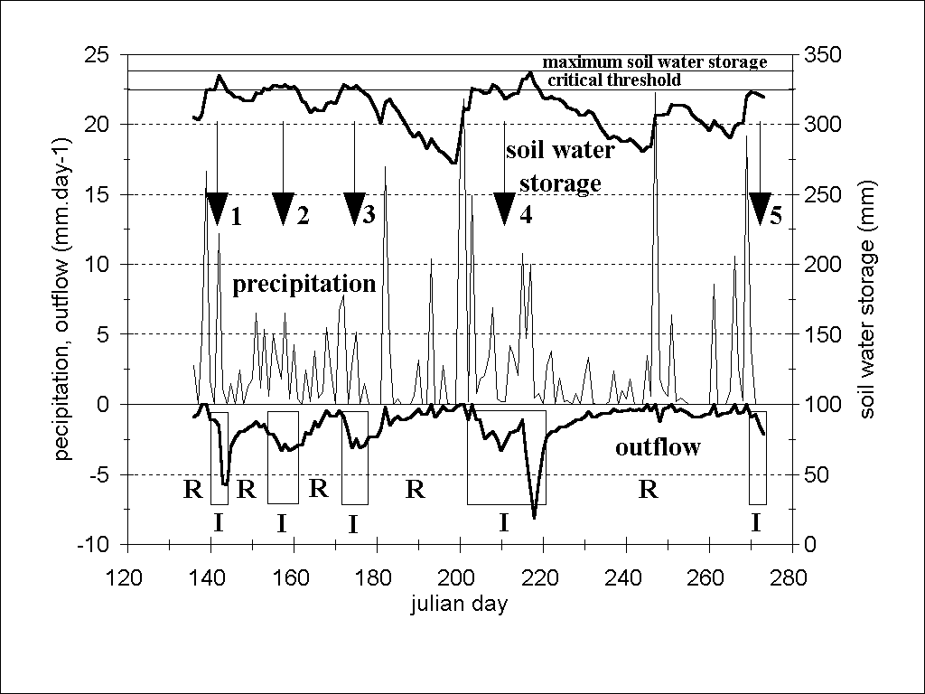
Fig. 1. The results of the transformation of precipitation to outflow of soil water to strata underlying the soil profile as simulated by SWAP Model for the Zabrod – meadow locality during 1987 growing season. Soil profile is taking into account as a transformer of precipitation to outflow. Boxes marked “I” in the bottom of the figure represent events of the instability-driven preferential flow arised after the overstepping of the critical threshold of the soil water storage water (events No. 1 – 5 producing the instability-driven preferential flow events marked “I”).

Based on our experimental experience is apparent that the preferential flow is even more universal event than it was supposed. The existence of the preferential flow in the structural homogeneous porous media was experimentally verified in the space scale from tenths of ccm to m³ up to small watersheds (cca 1 km²). The various experimental techniques were used:
- measurement of the wetting front movement in the soil column with the use of gammascopic method (Prazak et al., 1988b);
- vizualization of the fluid transfer in the two dimensional micromodel of porous medium (Prazak et al., 1988a, 1992);
- vizualization of the fluid transfer in the three dimensional porous medium composed from glass balls using computer controlled tomography CCT and computer controlled angiography CCA;
- measurement of the free drainage from porous medium composed from glass balls (Prazak et al., 1992);
- measurement of the free drainage from sand layer (Prazak et al., 1992);
- in situ measurement of the ponding infiltration with the aid of radionuclide tracers (Lichner,1995, Mdaghri et al., 1997, Sir et al., 1997, Lichner at al., 1999);
- in situ measurement of the infiltration from rain with the aid of radionuclide tracers (Lichner, 1995, Mdaghri et al., 1997, Sir et al., 1997, Lichner at al., 1999);
- measurement of the outflow in the closure profile of a small watershed under the monitoring precipitation and tensiometric pressures in the soil profile (Warmerdam et al., 1997, Tesar, Sir; 1998).

Theory of preferential flow in structural homogeneous porous media was worked out both on the microscopic and macroscopic level:
- microscopic level: an analogy to Brown's movement (Prazak et al., 1988b);
- macroscopic level: percolation theory of inflltration, redistribution, free drainage, air pressure displacement of water and isothermal evaporation (Sir et al., 1996a, 1996b).

Essential non-homogeneity of water transfer in the pores microscale is represented as a preferential flow in the macroscale of porous medium.

Without wishing to generalize our temporary findings the following conclusions can be drawn:
1. On the macroscopic level, the differences between heterogeneity-driven preferential flow and essential non-homogeneity of water transfer are negligible.
2. Soil proflle is suddenly drained when the soil water storage reaches of its characteristic maximum value.
3. This drainage is composed from some oscillatory outflow events.
4. Preferential flow and diffusion type flow can be met parallel at the practically same conditions.
5. Flow models based on Richards' equation are adequate in conditions of matrix flow.

Acknowledgements
The authors acknowledge the support of Grant Agency of the Czech Republic (Grants No. 526-98-0805 and 103-99-1470) and Grant Agency of the Academy of Sciences of the Czech Republic (Grant No. A3060001).

References
Beven, K. - Germann, P.: Macropores and water flow in soils. Water Resour. Res., 18,1982, p. 1311-1325.
Dekker, L. W. - Ritsema, C. J.: Uneven moisture patterns in water repellent soils. Geoderma, 70, 1996, p. 87-99.
Faeh, A. O. - Scherrer, S. - Naef, F.: A combined field and numerical approach to investigate flow processes in natural macroporous soils under extreme precipitation. Hydrol.Earth System Scinces, 4, 1997, p. 787-800.
Kung, K.-J. S. - Donohue, S. V.: Improved solute-sampling protocol in a sandy vadose zone using ground-penetratin radar. Soil Sci. Soc. Am. J., 55, 1991, p. 1543-1545.
Lichner, L.: A nuclear tracer technique for investigation of solute transport in the unsaturated zone. In: Leibundgut, Ch. (ed.): Tracer technologies for hydrological systems. IAHSPubl. No. 229, 1995, p. 109-116.
Lichner, L. - Germann, P. - Mdaghri Alaoui, A. - Sir, M.: Impact of land-use change on non-reactive fertilizer penetration into a clay-loam soil. In: Steenvoorden, J. (ed.): Proc.Int. Symp. Impact of land use change on nutrient loads from diffuse sources, Birmingham 1999. IAHS Publ., Wallingford, 1999, in press.
Mdaghri Alaoui, A. - Germann, P. - Lichner, L. - Novak, V.: Preferential transport of water and 131 Iodine in a clay loam assessed with TDR-technique and boundary layer theory. Hydrol. Earth System Sciences, 4, 1997, p. 813-822.
Prazak, J. - Tywoniak, J. - Sir, M.: Einige Bemerkungem zur Begriff des kritischen Feuchtigkeitsgehaltes. Gesundheits - Ingenieur - Haustechnik - Bauphysik - Umwelttechnik, 109, 1988a, p. 258-261.
Prazak, J. - Tywoniak, J. - Peterka, F. - Slonc, T.: Description of transport of liquid in porous media - a study based on neutron radiography data. Int. J. Heat Mass Transfer, 33,1990, p. 1105-1120.
Prazak, J. - Sir, M. - Kubik, F. - Tywoniak, J. - Zarcone, C:: Oscillation phenomena in gravity-driven drainage in a coarse porous media. Water Resources Research, Vol. 27,No. 7, 1992, p. 1849-1855.
Prazak, J. - Sir, M. - Kuraz, V. - Zarcone, C.: Microscopic aspects of the infiltration of rainwater into light-textured soil (In Czech). Meliorace, 24, 1988b, p. 127-138.
Steenhuis, T. S. - Ritsema, C. J. - Dekker, L. W.: Introduction to special issue: Fingered flow in unsaturated soil: from nature to model. Geoderma, 70, 1996, 83-85.
Sir, M. - Kubik, F. - Tesar, M. - Prazak, J.: Liquid transport in porous media - discontinuous phenomena. Part I: Theory. J. Hydrol. Hydromech., 44, 1996a, p. 81-90.
Sir, M. - Kubik, F. - Tesar, M. - Prazak, J.: Liquid transport in porous media - discontinuous phenomena. Part II: Examples. J. Hydrol. Hydromech., 44, 1996b, p. 235-251.
Sir, M. - Tesar, M. - Prazak, J. - Lichner, L.: In-situ measurements of soil water dynamics in small catchments. In: Cunnane, C. (ed.): Proc. Int. Symp. Hydrology of small agricultural catchments, The Hague 1996. Galway, 1997, p. 21-28.
Tesar, M. - Sir, M.: Influence of land use on the water regime of soil in the head water regions, Czech Republic. In: Haigh, M. J. - Krecek, J. - Rajwar, G. S. - Kilmartin, M.(eds.): Proc. of the Fourth. Intern. Conf. on Headwater Control, Merano, Italy, April1998. A. A. Balkema, Rotterdam, Brookfield, 1998, p. 357- 363.
Warmerdam, P. M. M. - van den Eertwegh, G. A. P. H. - Eliáš, V. - de Rooij, G. H. - Sir,,M. - Tesar, M: Process studies in agricultural catchments. In: Third report: 1994-1997, FRIEND - Flow Regimes from International Experimental and Network Data, UNESCO Paris, June 1997, Chapter 6 - Physical processes, p. 330-337.

