ABSTRACTS

INYS workshop on hydrology

19-21 June 2005, Smolenice

COMPARISON OF POOLING SCHEMES FOR FLOOD FREQUENCY ANALYSIS IN SLOVAKIA

Ida Kriegerová
Faculty of Civil Engineering, Dept. of Land and Water Resources Management
Slovak University of Technology, Bratislava, The Slovak Republic
kriegerova@svf.stuba.sk

Grouping of sites into homogeneous pooling group is the first major step of regional flood frequency analysis. During last years researchers have attempted to develop methods in which similarity between sites is defined in a multidimensional space of catchment-related characteristics or statistical characteristics.
This paper compares three pooling schemes application for flood frequency analysis in mid-sized slovak catchments. The pooling schemes are the cluster analysis, regression trees and an approach based on seasonality measure. Annual maximum discharges data from 198 subcatchments in area from 16 to 350 km², and four physiographic catchment characteristic are used in the analysis. For the delineated regions Hosking and Wallis’s homogeneity test have been used to estimate the degree of heterogeneity in a group of catchments and assess whether the group can be treated as a homogeneous pooling group. The map outputs expressed the graphic presentation of results, which show the spatial distribution of pooling groups within Slovakia using different grouping methods.
Further, the delineation of homogeneous pooling groups allows the performance of any regional estimation of flood quantiles method at the site of interest.

Keywords: annual maximum discharges, cluster analysis, regression tree, seasonality, homogeneity test

REGIONAL PROCESSING OF SOIL DROUGHT INDICATORS: CONDITIONAL HYDROLIMITS AND WATER STORAGE CAPACITY

Tomáš Orfánus
Institute of Hydrology SAS, Racianska 75, 831 02 Bratislava, orfanus@uh.savba.sk

Potential reserves of water in the effective soil depth for agrocoenoses (crops, permanent cultural grassy vegetation), designated as the water storage capacity, and relevant hydrolimits (field water capacity, wilting point) are presented as quantitative parameters for evaluation of accumulation function of soil (AFS) and drought-threat. A progressive spatial and pedo-transfer approach to estimation of hydrolimits and water storage capacity was used in the region of the Záhorská nížina Lowland. Water retention curves (WRC) were derived from soil data of Complex Agricultural Soil Survey digital database (KPP DB) using pedo-tranfer functions (Rosetta model). Relevant outputs were spatially processed using geostatistics and GIS to raster formats with pixel size of 200 x 200 m. Finally, they were delimitated as a function of (i) particle size composition units (ii) genetic soil units and (iii) pedo-ecological regions. Quantification and spatial estimation of AFS should be one of the basic steps for complex geoecological evaluation and delimitation of agricultural land considering drought-threat, groundwater pollution, runoff, soil erosion and some other important landscape-ecological factors.

Key words: accumulation function of soils, soil quality, water storage capacity, root zone, water retention curves, hydrolimits, Záhorská nížina Lowland, pedotransfer functions, GIS

UNCERTAINTY QUANTIFICATION IN POOLED FLOOD FREQUENCY ANALYSIS

Thomas Rodding Kjeldsen, Centre for Ecology & Hydrology, Maclean Building, Crowmarsh Gifford, Wallingford, OX10 8BB, UK.
trkj@ceh.ac.uk

The standard for conducting flood frequency analysis in the UK, as set out in the Flood Estimation Handbook¹ (FEH), is based on the index flood method combined with the Generalised Logistic (GLO) distribution. The parameters are estimated using the median of the annual maximum flood as the index flood and using the method of L-moments to estimate the parameters of the growth curve. For a given target site, a region-of-influence approach is used, involving the creation of a collection of hydrologically similar gauged catchments (pooling-group) from which an average growth curve can be derived.

This presentation examines the sampling uncertainty of quantile estimates as described in the FEH, i.e. based on pooling-groups and use of the median as the index flood. Analytical approximations for the variance of the quantile estimates were derived, based on asymptotic theory, for the single site case and then extended to the pooled analysis. Assuming the quantiles are normally distributed, the 95% confidence interval around the flood frequency curves can be derived for both single-site and pooled analysis as shown in Figure 1 and 2 below.

Figure 1: Single site analysis Figure 2: Pooled analysis

A series of bootstrap experiments were conducted to quantify and to develop generalised expressions of intersite dependence to be included in the analysis. It is shown that the pooled analysis yields narrower confidence intervals than the single-site analysis and that the presence of intersite correlations increases the sampling uncertainty. The method was extended to encompass estimation of the uncertainty at ungauged sites in the UK based on a regression model for the index flood, which significantly increases the prediction uncertainty compared with using an estimate of the index flood derived from observations at the target site.

References
- Institute of Hydrology (1999) Flood Estimation Handbook. Institute of Hydrology, Wallingford, UK.

MODELLING FLOW PROCESSES IN THE CHALK UNSATURATED ZONE

A.M. Ireson, Imperial College London, UK, andrew.ireson@ic.ac.uk

Introduction
The English Chalk is a very important water resource, however, the processes controlling the movement of both water and solutes through the unsaturated zone of the Chalk are not yet fully understood. Extensive experimental work is being carried out in the Pang and Lambourn catchments in Berkshire, UK, under the Lowland Catchment Research Programme, LOCAR. Recharge sites in these catchments are instrumented to collect soil physics data. These include measurements of water content and matric potential, as well as input (precipitation) and output (evaporation and recharge) fluxes. Measurement of these variables is by no means trivial, and all data should be treated with a degree of scepticism. Notwithstanding this fact, this paper reports the results of work that has been carried out using these data to attempt to parameterise a numerical model for the flow processes in the Chalk unsaturated zone.

Modelling the unsaturated Chalk
Chalk comprises of a fine-grained porous matrix (high porosity 20-45%, low permeability <10⁻²m/day) intersected by a fracture network (low porosity <2%, high permeability >10⁻²m/day) [1]. Consequently the movement of water and solutes within and between these two domains is complex. However, unlike some other dual porosity systems, in the Chalk the matrix is always saturated, due to the low air entry pressure associated with the small (<1m) pore throats. A numerical model for unsaturated flow in the Chalk was presented by Mathias in chapter 4 of his PhD thesis [2]. It was demonstrated theoretically that the time for the water in the matrix and fractures to reach pressure equilibrium would be < 10⁻² days, which was deemed sufficiently small to justify assuming a single pressure head field for both domains. This allows the Chalk to be represented with standard Richards’ equation using bulk properties for water content, , specific capacity, C, and hydraulic conductivity, K:

$\frac{∂θ}{∂t}=C\frac{∂ψ}{∂z}=\frac{∂}{∂z}\left[K\left(\frac{∂ψ}{∂z}−1\right)\right]$ with  = _{f} + _{m} C = C_{f} + C_{m} K = K_{f} + K_{m}
where  is the matric potential, and the subscripts f and m relate to the fracture and matrix continua. This equation can be discretised in space using finite differences, reducing the problem to a system of ordinary differential equations, which can be solved using one of the numerous ODE solver algorithms available. (Note this model structure is not appropriate when considering solute transport as well as flow, because the equilibrium time of solutes moving by diffusion processes between the fractures and matrix is too large, as demonstrated by Mathias [2].)

This model requires that the ) and K() relationships can be represented effectively by a parametric model (such as the van Genuchten or Brooks and Corey model for ), and the Burdine or Mualem model for K(), which are reviewed by Mathias [2].). The challenge then is to parameterise these relationships using field data. Previous workers have attempted to do this for the Chalk, such as the study by Cooper et al. (1990) [3]. However the data quality and quantity available from the current monitoring offers the possibility of an improved characterisation of these relationships, and in particular insights into the possible significance of hysteresis.

Objectives
The objective of this study is to use high quality field data to firstly parameterise the bulk fracture-matrix hydraulic properties of the unsaturated Chalk, and consequently use these relationships to simulate flow through the unsaturated zone of the Chalk. The model simulation can be verified against the same field data, as well as the water table response. A major research aim is to use this study to perform a critical assessment of the numerical model presented by Mathias. However, for the purposes of this presentation, it is hoped that the analytical methodologies employed in this study will be useful to those interested in understanding and modelling of the unsaturated zone.

- Price, M., Downing, R. A., and Edmunds, W. M. (1993). The Chalk as an aquifer. In Downing, R. A., Price, M., and Jones, G. P., editors, The Hydrogeology of the Chalk of North-West Europe, Oxford. Clarendon Press.
- Mathias, S. A. Modelling flow and transport in the Chalk unsaturated zone. PhD thesis, Imperial College London.
- Cooper, J. D., Gardner, C. M. K., and MacKenzie, N. (1990). Soil water controls on recharge to aquifers. J. Soil Sci.,41:613-630.

FACTORS CONTROLLING SEDIMENT DYNAMICS DURING RAINFALL-RUNOFF EVENTS IN A SMALL BASIN

Peter Bača, Institute of Hydrology, Slovak Academy of Sciences, Račianska 75, Bratislava,
831 02, Slovak Republik, e-mail: baca@uh.savba.sk

The behaviour of suspended sediment in watercourses is often a function of energy conditions, i.e. sediment is stored at low flow and transported under high discharge conditions. However sediment transport rates are also a function of sediment availability. The changes in sediment availability result in so-called hysteresis effects. Most studies on suspended sediment dynamics during single hydrological events were performed in large rivers. Less is known, however, about hysteresis effect and sediment transport from small agricultural basins, which can be considered as one of the most important sediment sources. Therefore, the aim of this study is to improve understanding of the behaviour of the suspended sediment dynamics during rainfall-runoff events and to investigate temporal variability of sediment availability in a small agricultural basin. For this study the experimental micro-basin Rybárik near Považská Bystrica (Western Slovakia) with an area of 0.12 km² was selected. Suspended sediment concentrations and discharge values were measured with high frequency of sampling during single floods. For single rainfall-runoff events occurred in the Rybárik basin, the following factors controlling sediment dynamics were distinguished: amount and the distance from sources of available sediment to the channel network, wave volume and peak discharge of the preceding flood, time interval between two rainfall-runoff events.

EARTHQUAKE-AND-STORM-DRIVEN INCREASES IN SEDIMENT DELIVERY FROM AN ACTIVE MOUNTAIN BELT

Simon J. Dadson et al.
Centre for Ecology and Hydrology, CEH Wallingford, Maclean Building,
Crowmarsh Gifford, Wallingford, Oxon, OX10 8BB, UK.

Erosion controls the topographic and structural evolution of mountain belts and is the main source of sediment delivered to the oceans. The aims of this thesis are to quantify the controls on erosion rates in the Taiwan mountain belt across a range of time-scales. Erosion rates in the Taiwan orogen are estimated from modern river sediment loads, Holocene river incision rates, and thermochronometry on a million-year time-scale. Erosion rates within the actively deforming mountains are high (3–6 mm yr⁻¹) on all time-scales, but the pattern of erosion has changed over time in response to the migration of localized tectonic deformation. Modern, decadal erosion rates correlate with historical seismicity and storm-driven runoff variability. The highest erosion rates are found where rapid deformation, high storm frequency and weak substrates coincide, despite low topographic relief (Dadson et al., 2003).
The geomorphic impact of individual earthquakes and typhoons is analysed through the natural experiment provided by the 1999 M_{w} 7.6 Chi-Chi earthquake and subsequent typhoon storms. Following the Chi-Chi earthquake, a 2–4-fold increase in sediment concentration was found in rivers draining the epicentral region. Sediment was transferred from hillslopes to rivers in a cascade of processes. The earthquake triggered widespread landslides on hillcrests leaving large amounts of debris stored on hillslopes, and subsequent typhoons triggered landslides and debris flows, which reworked this material and triggered new landslides in bedrock that was weakened by co-seismic ground motion (Dadson et al., 2004).
Rivers draining the Taiwan mountain belt deliver 384 Mt yr⁻¹ of suspended sediment to the ocean. This amount represents 1.9% of estimated global suspended sediment discharge, yet is derived from only 0.024% of the Earth’s subaerial surface. Much of this sediment is delivered in hyperpycnal river plumes that sink to the sea-bed and may deposit turbidites. It is estimated that the rate of turbidite deposition increased by approximately 4 times following the Chi-Chi earthquake (Dadson et al., in press).
The links between erosion, climate, tectonics, lithology, and relief are discussed, and the possibility of observing geomorphic signals of palaeoseismicity, palaeohydrology, and palaeoclimate in the stratigraphic record is considered. Further work is suggested to use the data from Taiwan to constrain surface process models of mountain belt evolution and to develop further understanding into the physical nature of co-seismic sediment supply and onward transport in river channels.

- Dadson, S. J., Hovius, N., Chen, H., Dade, B., Hsieh, M. L., Willett, S. D., Hu, J. C., Horng, M. J., Chen, M. C., Stark, C. P., Lague, D., and Lin, J. C., Links between erosion, runoff variability and seismicity in the Taiwan orogen. Nature, 426: 648-651 (2003).
- Dadson, S. J., Hovius, N., Chen, H., Dade, B., Lin, J. C., Hsu, M. L., Lin, C. W., Horng, M. J., Chen, T. C., Milliman, J., Stark, C. P., Earthquake-triggered increase in sediment delivery from an active mountain belt. Geology, 32(8): 733–736 (2004).
- Dadson, S. J., Hovius, N., Pegg, S. A., Dade, W. B., Horng, M. J., and Chen, H., Hyperpycnal sediment delivery from the Taiwan mountain belt to the ocean. Journal of Geophysical Research. (In press).

THE DEVELOPMENT OF A REGIONALISED MODEL FOR THE ESTIMATION OF NATURAL FLOW STATISTICS WITHIN UNGAUGED CATCHMENTS IN SCOTLAND

Tracey Goodwin
Centre for Ecology and Hydrology (CEH), Wallingford, Oxfordshire, OX10 8BB, UK, e-mail: tgo@ceh.ac.uk

Within Scotland natural low flow statistics can provide water resource managers with the information required to assist in achieving the requirements of the Water Framework Directive, to assess hydropower potential within upland rivers and to improve the regulation of abstractions and discharges within river reaches. Many rivers in Scotland are ungauged hence there is a requirement for a methodology which can be used to estimate natural low flows statistics within ungauged catchments. Multivariate models that relate flow statistics to the climatic and physical characteristics of the catchment have been developed within the United Kingdom since the 1970s. The methodology developed by Gustard et al., ,Report 101, was the preferred method for estimating flow statistics at ungauged sites within Scotland . Within England and Wales the multivariate methods were recently updated to that of a Region of Influence (ROI) approach which was subsequently implemented within the Low Flows 2000 software. Within the ROI methodology the standardised annual or monthly FDC is based on observed data from a selected data pool. The datapool is derived using similarity measures 3
related to the distribution of a hydrologically based soil classification system to derive catchment similarity. The standardised FDC is then rescaled using a value of runoff, estimated using historical rainfall and PE data together with a soil moisture model, to predict the FDC in units of cubic metres per second.. Whilst the main factors which influence low flow statistics, hydrogeology and climate, are the same within Scotland as England and Wales the dominant hydrogeology and climatic conditions are different. For example, there is a greater proportion of impermeable substrates and peat soils within Scotland than in the UK. Scotland is also wetter than the UK with the distribution of rainfall indicating an East/West trend which is closely correlated with the topography. A revised methodology, using the ROI approach, was developed for the estimation of natural low flow statistics at ungauged sites within Scotland. The results of the final model can be seen within Table 1. This indicates a substantial improvement in the systematic error (BIAS) and a small reduction in the random error (RMSE) when compared with the previous methodology. The improved methodology was implemented within the Low Flows 2000 software to provide a rapid, consistent methodology for estimating natural low flow statistics.
Table 1
 | BIAS | RMSE  (ls⁻¹km⁻²)
Report 101 | -12.3 | 1.48
LF2000 Methodology | -0.8 | 1.45

OBSERVED CHANGES IN EXTREME RAINFALL AND IMPLICATIONS FOR FLOOD RISK IN THE UK: CLIMATIC VARIABILITY OR THE FIRST SIGNS OF CLIMATE CHANGE?

Hayley J. Fowler and Chris G. Kilsby, Water Resource Systems Research Laboratory, School of Civil Engineering and Geosciences, University of Newcastle upon Tyne, UK, h.j.fowler@ncl.ac.uk

Increasing flood risk is now recognised as the most important sectoral threat from climate change in most parts of the world. The recent repeated severe flooding in the UK and Europe have caused major loss of property and life, and the insurance industry are now threatening the withdrawal of flood insurance cover from millions of UK households. There has been much public debate on the apparent increased frequency of extreme weather events and this has focussed attention in particular on the perceived increase in rainfall intensities. Climate model integrations predict increases in both the frequency and intensity of heavy rainfall in the high latitudes under enhanced greenhouse conditions which would be expected to cause increased risk of flooding. These projections are consistent with recent increases in rainfall intensity seen in the UK and worldwide.

Using a statistical method called regional frequency analysis; we have examined 204 rainfall records across the UK in 9 homogeneous climatic regions for evidence of change in extreme events. It is clear from our research that there have been significant changes to both the timing and occurrence of multi-day intense rainfall events over the past decade. We estimate that the magnitude of multi-day extreme rainfall has increased two-fold over parts of the UK since the 1960s. Intensities previously experienced every 25 years now occur at 6 year intervals; more analogous to regional climate model estimations for the end of the 21st century. Indeed, the observed patterns of change are very similar to those projected under climate change (Figure 1). There have also been changes in timing, with extreme events now predominating in autumn months. These climatic changes may be explained by persistent atmospheric circulation anomalies and have huge economic and social implications in terms of increased flooding.

Figure 1: Comparison of estimates of 10-day duration, 25-year return period (or 4% chance) rainfall event for both observed and regional climate model data. a, observed 1961-1990. b, observed 1991-2000. c, HadRM3 control (1961-1990) scenario, ensemble mean d, HadRM3 future (2070-2100) scenario, ensemble mean.

Fowler, H.J. and Kilsby, C.G. 2003. A regional frequency analysis of United Kingdom extreme rainfall from 1961 to 2000. International Journal of Climatology, 23(11), 1313-1334.
Ekström, M., Fowler, H.J., Kilsby, C.G. and Jones, P.D. 2005. New estimates of future changes in extreme rainfall across the UK using regional climate model integrations. 2. Future estimates and use in impact studies. Journal of Hydrology, 300(1-4), 234-251.
Fowler, H.J. and Kilsby, C.G. 2003. Implications of changes in seasonal and annual extreme rainfall. Geophysical Research Letters, 30(13), 1720, doi:10.1029/2003GL017327.

IMPLEMENTATION OF LOW FLOW ESTIMATION IN THE UK

Matthew Fry, CEH Wallingford, Wallingford, Oxon, OX10 8BB, UK, mfry@ceh.ac.uk

Low flow statistics in the UK have a wide variety of uses including licensing of abstractions and discharges, viability assessment for hydropower, and input to assessments of ecological status for national studies and the EU Water Framework Directive. Statistics for ungauged sites, including mean flow and natural flow duration curves, are estimated using a region of influence model developed by the Centre for Ecology and Hydrology (1, 2). These models are fairly data intensive and the time series and spatial information required comes from numerous sources, making application complex. The implementation of systems to allow the models to incorporate diverse data sources and quickly create consistent results has vastly increased the uptake of models and the availability of low flow statistics in the UK.

Low Flows 2000 is a GIS-based system which allows users to estimate low flow statistics at ungauged sites within a user-friendly software environment. Sites of interest are selected within a GIS interface displaying the river network, maps of various scales and other sources of contextual spatial information. Catchments are automatically derived by the intelligent use of digital terrain models. Catchment characteristics are retrieved from datasets of soils, rainfall, evaporation and other spatial data sources. These catchment characteristics are then fed through the hydrological models. In addition, local datasets of licensed water use show the current impact of artificial influences on natural flow regimes and users can model the impacts of future water use scenarios. Flow estimates can be compared to gauged flow series and discharge measurements.
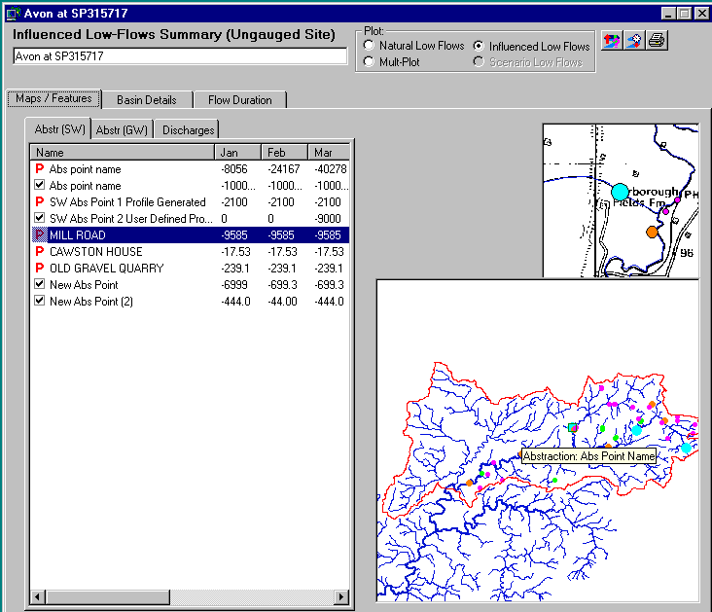 | 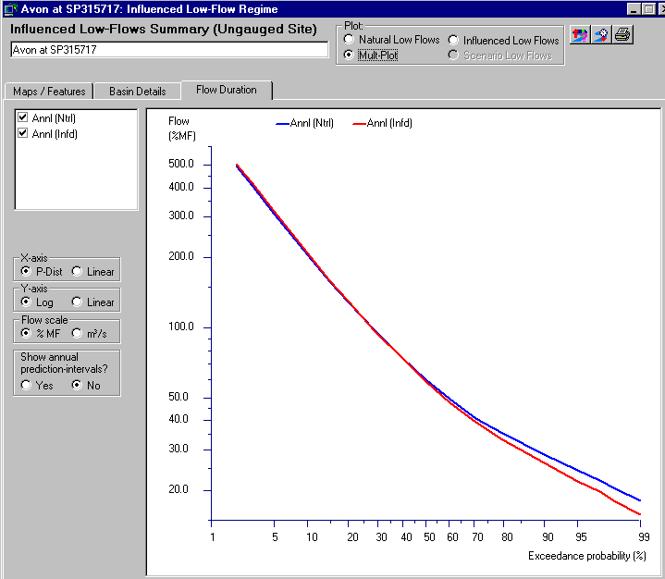
Examples of software screens showing defined catchment boundary and water use within the catchment (left) and comparison of estimated natural and influenced flow duration curves (right)

At the smallest scale users across the country use the system to estimate the impact of individual licences and set usage conditions accordingly; at the medium scale national catchment management plans are assessed; at the largest scale the system has been automated to produce the impacts of water use at 6000+ assessment points for the Water Framework Directive (3).

1. Holmes, M. G. R., A. R. Young, et al. (2002). A new approach to estimating Mean Flow in the UK. Hydrology and Earth System Sciences 6(4): 709-720.

2. Holmes, M. G. R., A. R. Young, et al. (2002). A region of influence approach to predicting flow duration curves within ungauged catchments. Hydrology and Earth System Sciences 6(4): 721-731.

3. Goodwin, T. H., Fry, M.J., Holmes, M. G. R., Young, A. R. (2004) The Utility of GIS Delivered Environment Models in the Characterisation of Surface Water Bodies under the Water Framework Directive: Low Flows 2000 – a Case Study. Pahl, C., Schmidt, S. and Jakeman, T. (eds)

WATER OUTFLOW CONTROL FROM A RESERVOIR BY FUZZY REGULATOR DURING THE FLOOD PASSAGE

Ing. Lubomír Jaroš, Brno University of Technology, Faculty of Civil Engineering, Veveří 331/95, 602 00 Brno, Phone n.: +420541147771, jaros.l@fce.vutbr.cz

The main content of this contribution is used of fuzzy logic for operational water outflow control during the flood passage. The model of isolated storage reservoir during the flood passage was made in the interactive environment Matlab 6.1 and this model is filled in fuzzy-regulator, which is able to determine from continuous timing diagram of command input and continuous moving stage in water reservoir in each of time step identified change of output value, which in this case is change of bottom outlet.

Fig. 1.: Matrix of base rules for the fuzzy regulator 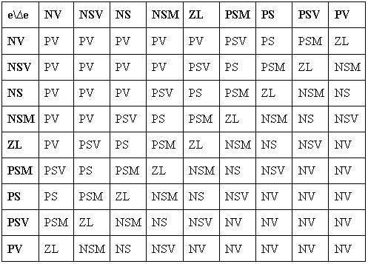

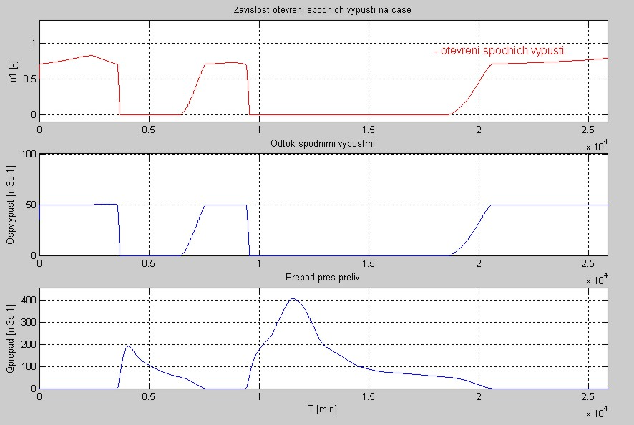
Fig. 2.: Graphic outputs from the numerical model

FLOOD FORECASTING FOR THE UPPER HRON RIVER BASIN

Richard Kubeš, Marcel Zvolenský

The paper examines the applicability of medium range quantitative precipitation forecasts in a flood forecasting and warning system and the applicability of the Hron rainfall-runoff model for these purposes. The presented results were obtained within the framework of the 5 EU FP project “European Flood Forecasting System” (De Roo, A.P.J., et al., 2003). As a pilot basin for this project the upper part of the Hron river basin with an area of 1766 km² was chosen, and considered as representative for mountainous regions where flood generation from cyclonic rainfall and snow melting processes play an important role. A conceptual lumped hydrological model developed at the Slovak University of Technology in Bratislava (Kubeš, 2003) was used for runoff modelling. The model was calibrated and verified on data from the period 1991-1999. Meteorological forecasts prepared in the European Centre for Medium Range Weather Forecast (ECMWF deterministic model and ensemble forecasts), the Danish Meteorological Institute (DMI – Hirlam model) and the Deutscher Wetterdienst (DWD LM and GME model), and the ALADIN model were used to drive the hydrological model. Hindcasted flows for the floods, which occurred in the upper Hron river basin in July 1997 and August 2002, were compared with measured flows and the results discussed.

Key words: medium range precipitation forecast, flood forecasting, deterministic forecast, ensemble forecast, hydrological model, model comparison

SIMULATIONS OF THE FLOODS AT SLOVAK DANUBE RIVER WITH HISTORICAL INPUTS BY MODEL NLN – DANUBE

Veronika Mitková, Institute of Hydrology, Slovak Academy od Sciences, Bratislava, Slovakia

River regime conditions of the Danube River are always being changed. These changes result from the natural processes (erosion, sedimentation, vegetation cover) or anthropogenic activities (modification of the riverbank, construction of hydro–power stations). This has significant impact upon the water regime of the river. Channel training resulted in shortening of the flood wave travel times and changes of water levels in Danube river at Bratislava (Mišík, Capeková, 2001; Opatovská, 2002). Due to water flow changes on Danube river it is not possible to determine the range of hydrological characteristics (for ex. Q₁₀₀) only from the range of historical discharges at given station. For example based on simulation such meteorological situation, as occurred in 1899 would cause diametrically different hydrograph shape of flood wave on Danube River at Bratislava at present. The estimation of the discharge value for present conditions is possible only by simulations. For this purpose simple river model NLN – Danube (Svoboda 1993; Pekár et al., 2001) was configured.Model NLN - Danube (Pekár et al., 2001) goes out from model NONLIN by A. Svoboda (1993, 2000). Model of each section of the simulated system is based upon the concept of a series of equal non-linear reservoirs, thus belong to the category of hydrological conceptual non-linear models.

A NOVEL APPROACH TO FLOOD FREQUENCY ANALYSIS WHEN INCORPORATING HISOTRICAL FLOOD INFORMATION: THE APPLICATION OF A HIGH THRESHOLD GENERALISED PARETO DISTRIBUTION.

Macdonald N., The School of Geography, Earth and Environmental Sciences, University of Birmingham, Edgbaston, B15 2TT. n.macdonald@bham.ac.uk

Reassessment of flood risk is pertinent in much of Europe considering an apparent increase in high magnitude floods since the early 1990s. The limitations inherent in flood estimation (relatively short gauged records) can be reduced with the inclusion of historical information when considering the largest events. Historical records represent an under-utilized resource in considering the frequency and magnitude of flooding. Increasingly historical flood records are incorporated into flood frequency analysis when estimating low probability events; methods of inclusion have developed considerably in recent years. The development of sophisticated analytical models although improving estimate reliability have increased application complexity, representing a significant problem in the effective communication and adaptation of methods by the practitioner. The increased application of historical augmentation within flood frequency analysis within the UK has increased the need for a relatively simplistic numerical approach (a relatively simple graphical approach is already available), which can be undertaken without considerable numerical training and modelling. A relatively simplistic generalised Pareto distribution (GPD) approach with a high threshold is proposed and assessed for the River Tay, Scotland.

The River Tay has the highest annual discharge in the UK; the catchment has little urban development except for several small towns and the historic city of Perth. A detailed documentary history is present at Perth, which includes records of several large floods. The period since 1815 is considered as it represents a timeframe of greater confidence in hydrological and climatic stationarity. The extended period provided by the historical record includes an additional twenty floods above the 1361 m³s⁻¹ threshold (only four are recorded during the gauged period).

The GPD approach considers only the largest events, removing the difficulties implicit in considering a large parent data series exhibiting several differing flood populations. The approach is only intended for use when considering the largest events, as it represents the overall parent population poorly. It is anticipated that the approach would be used as part of a multi-method analysis; comparative assessment against conventional flood frequency approaches suggests that the inclusion of the historical records provides valuable information in the estimation of high magnitude floods.
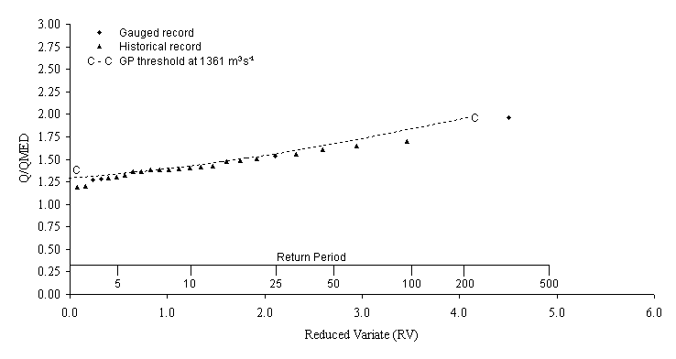
Fig 1: GPD curve, >1361 m³s⁻¹ threshold

SPATIAL VARIABILITY AND DEGREE OF SPATIAL ORGANISATION OF SOIL WATER CONTENT IN THE FIELD WITH HETEROGENEOUS SOIL COVER

Tomáš Orfánus, Institute of Hydrology SAS, Racianska 75, 831 02 Bratislava, orfanus@uh.savba.sk

Soil water content (SWC) is an important parameter regarding the land use and agriculture. It determines optimal soil conditions for the soil tillage and influences the microorganisms and enzyme activity. The knowledge on its spatial variability is crucial. The spatial organization of soil water content in tilled heterogeneous soils at a field scale was investigated using geostatistical methods. The subsoil horizon (10-20 cm in depth) was chosen in the process since it is the horizon of highest root density during the vegetation season and was not disturbed by the last vernal disking. The investigated area is flat, thus the influence of relief was avoided. The variation of soil water content follows the textural variations within the scope of research field and differs markedly for different textural classes. SWC fluctuates around 9 % in loamy sand and around 40% in clay loamy soil at the same time. The soil water content is highly non-stationary phenomenon if we deal with spatially heterogeneous soils. The data follow bi-modal distribution regarding the full data set, however the distributions of SWC data come close to normality after we divided the field according to textural class. The found ranges of spatial dependence correspond to correlation lengths of about 20 - 30 metres and are somewhat smaller for heavier clayey loam. It is assumed that the tillage has disturbed the spatial continuity of soil water content in one direction (south-north) in clay loamy soil.

KEY WORDS: field scale, soil water content, stationarity, soil heterogeneity

ESTIMATION OF LOW AND FLOOD FLOW INDICES USING REGIONALISED MODEL PARAMETERS

Juraj Parajka

For any practical application, the interest resides in how well the water balance dynamics, such as the spatial and temporal variations of flows can be estimated for a given catchment. The aim of this study is to compare the predictive accuracy of various regionalisation methods used for the transfer of model parameters and subsequently for the estimation of water balance dynamics (such as runoff components or low and flood flow indices) for the ungauged sites. We focus on the ungauged catchment case for which is simulation of daily water balance dynamics particularly difficult. We use a comprehensive data set of 320 Austrian catchments, where anthropogenic effects not or only slightly affect the hydrological regime. For the simulation of daily water balance dynamics over 11 years we applied the semi-lumped conceptual rainfall-runoff model, which allows to take into account the spatial variability of model inputs in each catchment. Predictive accuracy of different regionalisation approaches was assessed by the jack-knifing cross-validation. In a first step, model parameters were estimated for gauged catchments from regional information without using local runoff information. In a second step, the model efficiencies and selected water balance components simulated from these regionalised model parameters were compared to the model simulations obtained from at-site calibrated parameter values. This comparison then gives us a reliable measure of how well each of the methods performs for the ungauged catchment case.

THE AREAL DEPLETION CURVES – A METHOD FOR ESTIMATING THE VOLUME OF WATER IN SNOW

Zuzana Pecúšová

Snow is an important natural phenomenon in Slovakia. Contribution of snowmelt to discharge of Slovak rivers varies between 30 and 60%. The flood events caused by snowmelt are rare compared to those caused by rain. However, estimation of the amount of water stored in the snowpack is an important task of operational hydrology and hydrological research. Slovak Hydrometeorological Institute (SHMI) and Slovak Academy of Sciences (Institue of Hydrology) are currently the only Slovak institutions that deal with the estimates of water volume stored the snowpack.
The paper is focused at comparison of several methods of estimation of the amount of water stored in the snowpack. Except the simpler methods used in operational hydrology, the spatial distribution of snow water equivalent was also simulated using a carefully calibrated snow accumulation and melt model. The simulations allowed also calculation of snow depletion curves. Practical applicability of calculated snow depletion curves in operational hydrology will be tested in a simple snowmelt model.

INFLUENCE OF BOUNDARY CONDITIONS AND STRUCTURAL UNCERTAINTY ON FLOOD INUNDATION PREDICTIONS

Florian Pappenberger¹, Patrick Matgen², Keith Beven¹

¹ Lancaster University, Environmental Science, Lancaster, LA1 4YQ, f.pappenberger@lancaster.ac.uk
² Cellule de Recherche en Environnement et Biotechnologies, Luxembourg

Models which predict hydrological extremes and are based on scarce data still face the challenging problem of understanding of parameter uncertainty and sensitivity. In this study, the GLUE methodology is combined with Global Sensitivity Analysis, to establish the sensitivity of flood inundation predictions to uncertainties in the upstream boundary condition and bridges within the modelled region. This analysis can be used to guide a sampling strategy for rivers in flood, and thus provides an interesting feedback loop to field hydrologists. It can further guide our understanding of hydro-dynamic processes.
Most modellers assume an upstream discharge hydrograph as given. This is surprising, as it is known that input discharge can dominate flood inundation behaviour and most discharge records are still derived in many cases from rating-curves which convert measured water levels to discharge (see references [1]). Several different sources can be listed which influence the accuracy of rating curves (see [2]).
An uncertainty study of a flood inundation model should include more than just considerations of the upstream or downstream boundary. However, in most recent studies, the uncertainty of structural elements such as bridges is ignored, although they can have a significant impact on the flood inundation predictions. This is usually justified by the argument that such uncertainty will be compensated for by an effective value of surface roughness. This could be seen to invalidate the initial reasons for employing a physically based model. However, there are a wide variety of different ways of implementing such structures in different modelling packages and the modeller will have to choose from approaches of varying complexity.

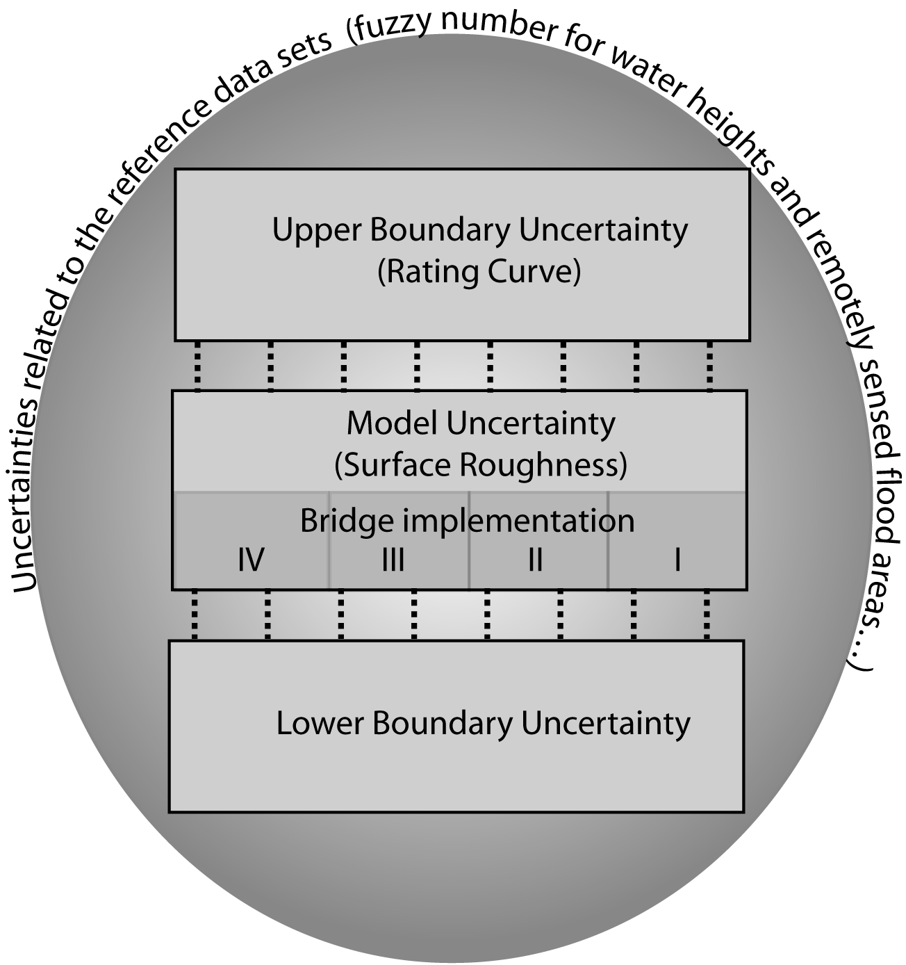
Figure 1: Uncertainties considered in this study

Several studies have highlighted the problem of determining effective surface roughness (see e.g. [3]). These studies suggest that the effective roughness parameters required at the scale of the model discretisation do not necessarily reflect the roughness, which is perceived as real. Figure 1 gives an overview of all the uncertainties considered in this study.
It can be shown that the upstream boundary can have significant impact on the model results, exceeding the importance of the model parameters in some areas. However, this depends on other internal boundary conditions and, for example, the amount of backwater within the modelled region. The type of bridge implementation can have large local effects, which is strongly influenced by the bridge geometry (in this case the area of the culvert).
Unfortunately no parameter set or model implementation that fulfills all evaluation criteria could be established. We propose four different approaches to this problem: closer investigation of anomalies; introduction of local parameters; an increase in the size of error bounds; resorting to local evaluation. Moreover, we show that it can be advantageous to decouple the classification into behavioural and non-behavioural data sets from the calculation of uncertainty bounds. This requires a choice of which set of performance criteria have to be satisfied for different types of predictions and which set of performance measures are used to actually compute the uncertainty bound. For example in this particular case a flood risk map can be derived for the time of the Envisat ASAR. The cumulative distribution function for each cross-section will be computed by using the performance measure at each cross-section rather than for all cross-sections. Figure 2 illustrates this risk map with the 10% and 90% percentile.

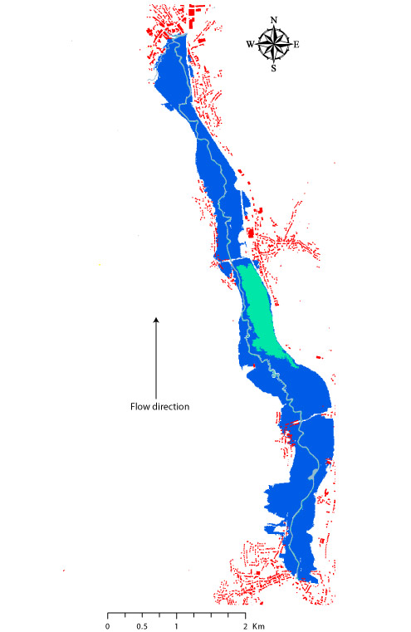
Figure 2:Flood Risk Map

1. Schmidt, A.R., Analysis of stage-discharge relations for open-channel flow and their associated uncertainties. 2002, Universitz of Ollinois: Urbana. p. 328.
2. Pelletier, P.M., Uncertainties in the single determination of river discharge: a literature review. Canadian Journal of Civil Engineering News, 1988. 15(5): p. 834-850.
3. Pappenberger, F., K.J. Beven, M. Horritt, and S. Blazkova, Uncertainty in the calibration of effective roughness parameters in HEC-RAS using inundation and downstream level observations. Journal of Hydrology, 2005. 302(1-4): p. 46-69.

Gustard, A., Marshall, D. C. W. and Sutcliffe, M. F. (1987). Low flow estimation in Scotland. Report 101. Institute of Hydrology. Wallingford.
Holmes, M. G. R., A. R. Young, et al. (2002). A new approach to estimating Mean Flow in the UK. Hydrology and Earth System Sciences 6(4): 709-720. 3 Holmes, M. G. R., A. R. Young, et al. (2002). A region of influence approach to predicting flow duration curves within ungauged catchments. Hydrology and Earth System Sciences 6(4): 721-731.
Fowler, H.J. and Kilsby, C.G. 2003. A regional frequency analysis of United Kingdom extreme rainfall from 1961 to 2000. International Journal of Climatology, 23(11), 1313-1334.
Ekström, M., Fowler, H.J., Kilsby, C.G. and Jones, P.D. 2005. New estimates of future changes in extreme rainfall across the UK using regional climate model integrations. 2. Future estimates and use in impact studies. Journal of Hydrology, 300(1-4), 234-251.
Fowler, H.J. and Kilsby, C.G. 2003. Implications of changes in seasonal and annual extreme rainfall. Geophysical Research Letters, 30(13), 1720, doi:10.1029/2003GL017327.
Parent E., and Bernier J., 2003, Encoding prior experts judgements to improve risk analysis of extreme hydrological events via POT modelling, Journal of Hydrology, 283: 1-18
Bayliss A.C. & Reed D.W., 2001, The use of historical data in flood frequency estimation, Centre for Ecology and Hydrology (NERC), Wallingford.
Werritty A., Paine J., Macdonald N., Rowan J.S. and McEwen L.J., (In press), Use of proxy flood records to improve estimates of flood risk: lower River Tay, Scotland, Catena

